Module 9: Lambda Assignment

Problem Statement:
You work for XYZ Corporation. Your corporation wants to launch a new web-based application and they do not want their servers to be running all the time. It should also be managed by AWS. Implement suitable solutions.
Tasks To Be Performed:
1. Create a sample Python Lambda function.
2. Set the Lambda Trigger as SQS and send a message to test invocations.
1. Creating the Lambda function: demoLambda-SQS-trigger-20-July
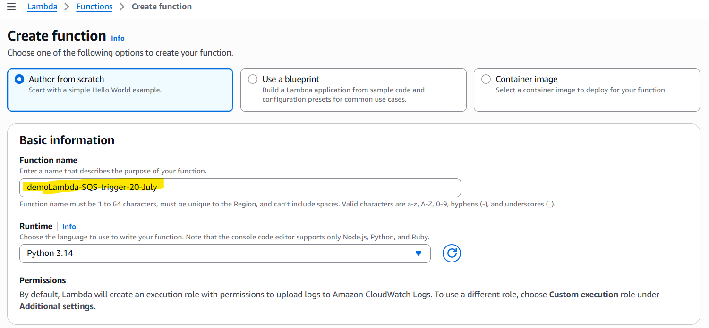
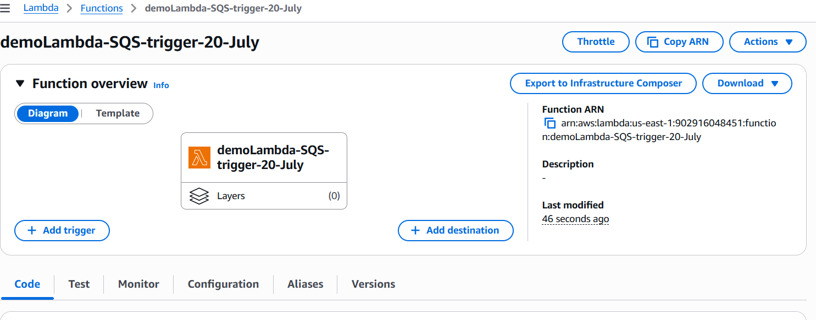
2. Code to process the event:
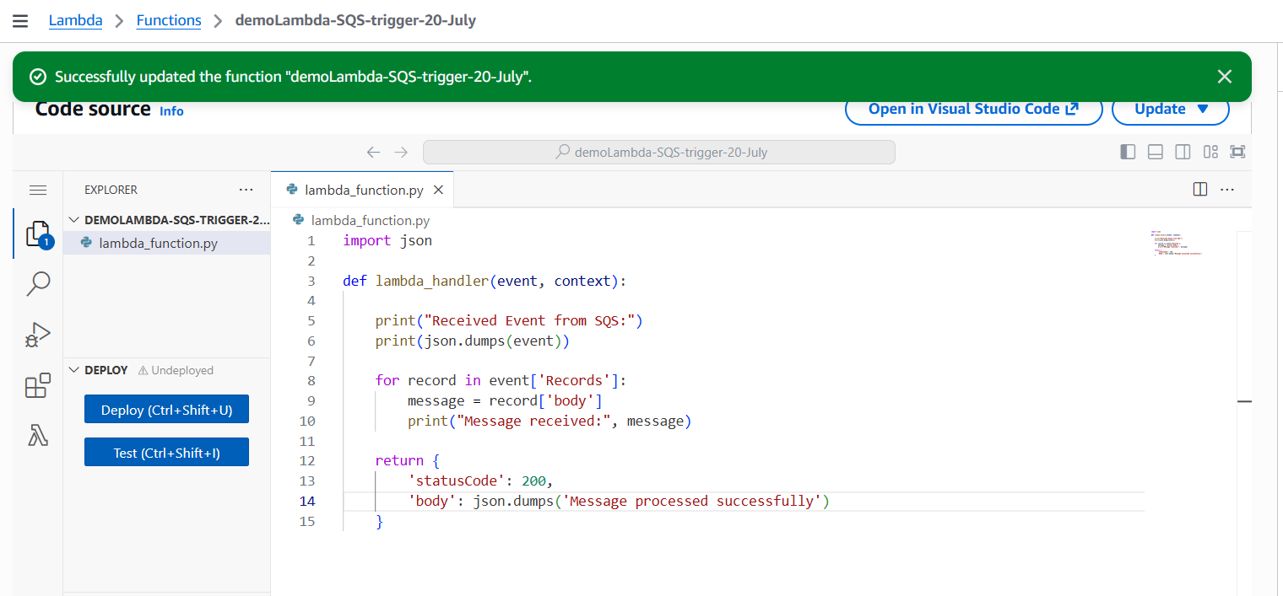
3. Creating the SQS queue: lambda-SQS-lab-27-july
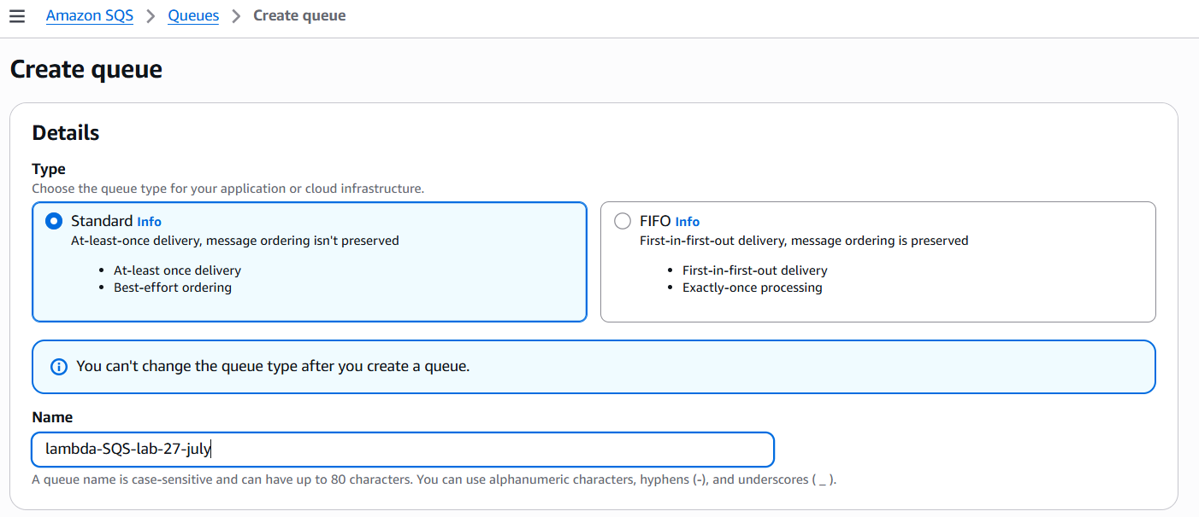
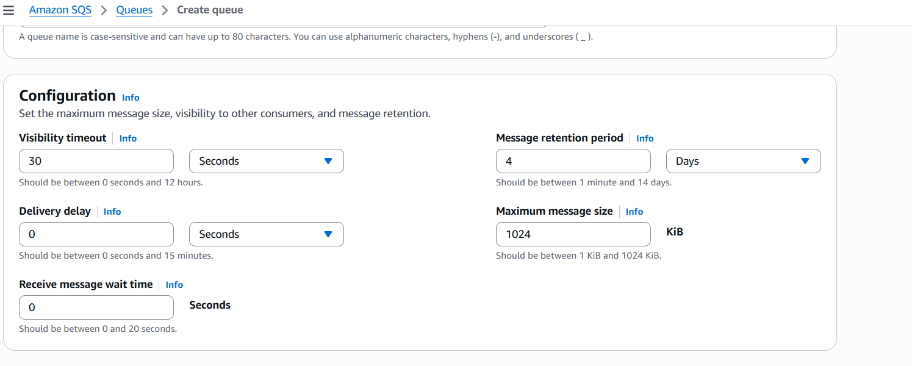
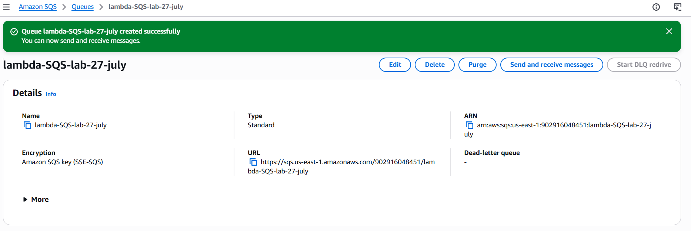
4. Add the Trigger: SQS, activate trigger.
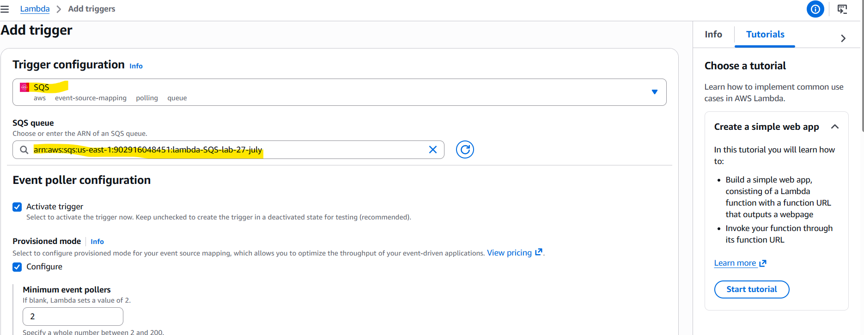
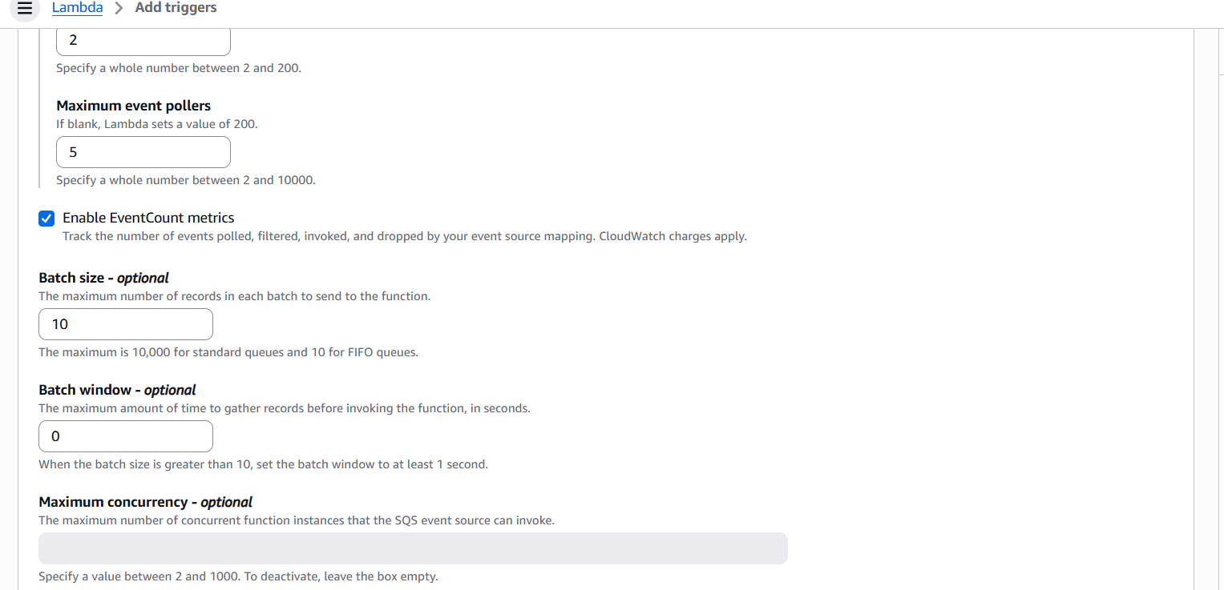
Error: Lambda execution role does not have permission to read messages from the SQS
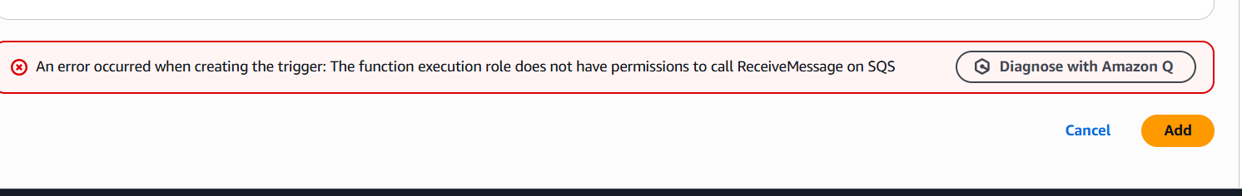
5. Adding the policy - AWSLambdaSQSQueueExecutionRole
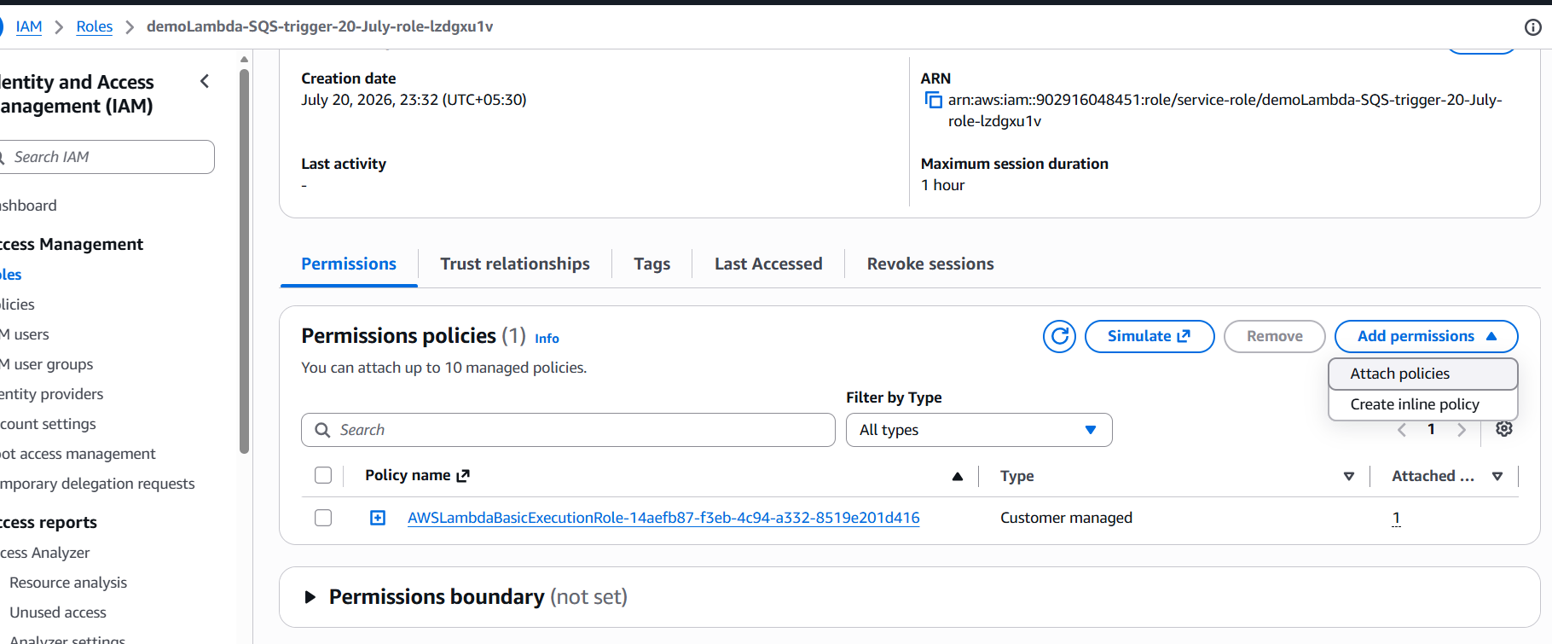
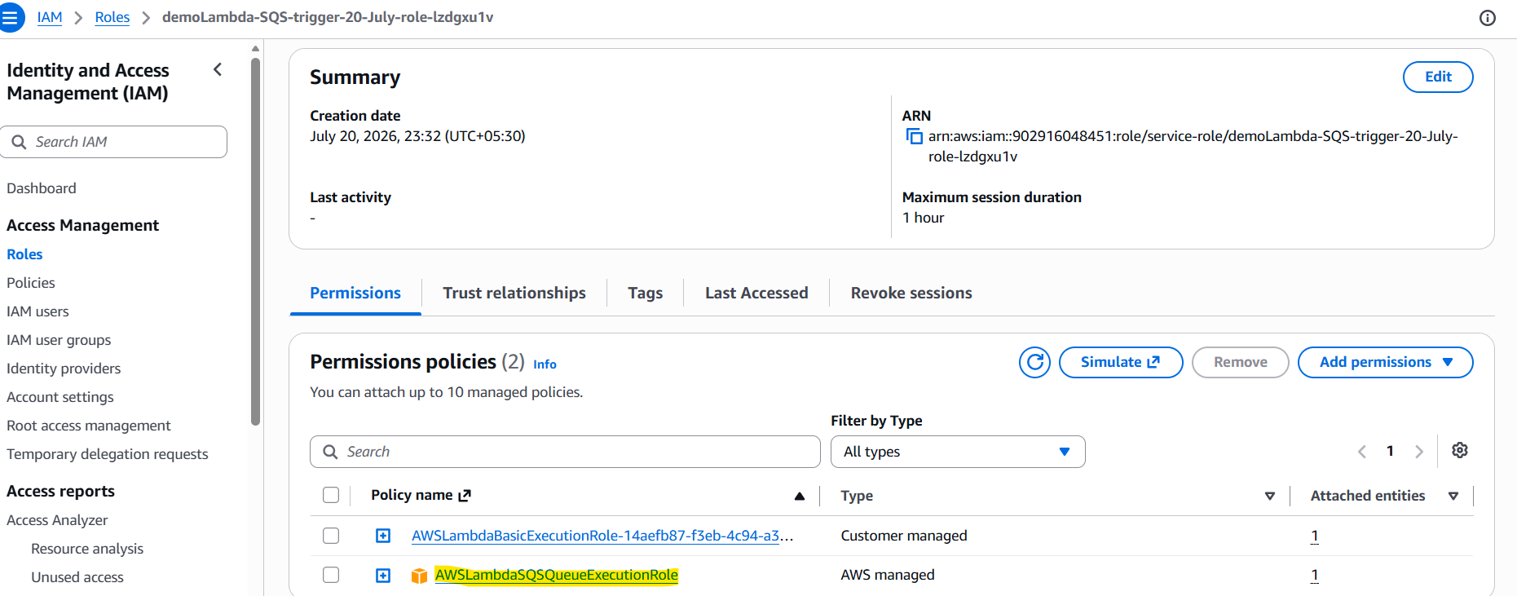
6. Added the trigger:
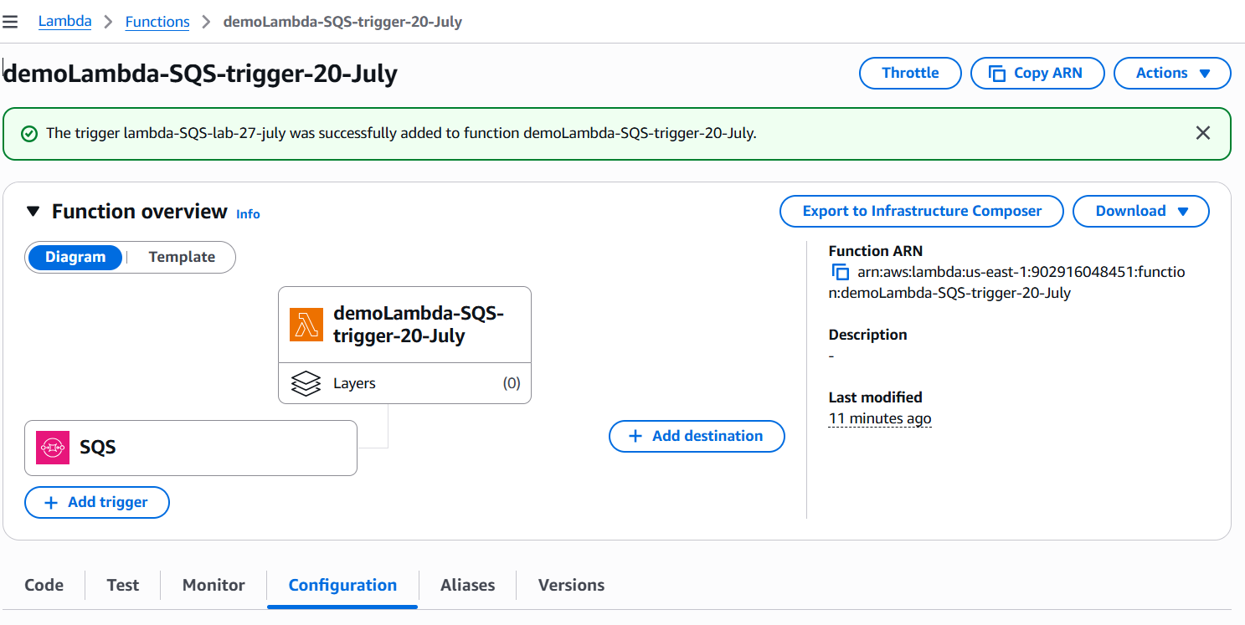
7. Sending message from the SQS:
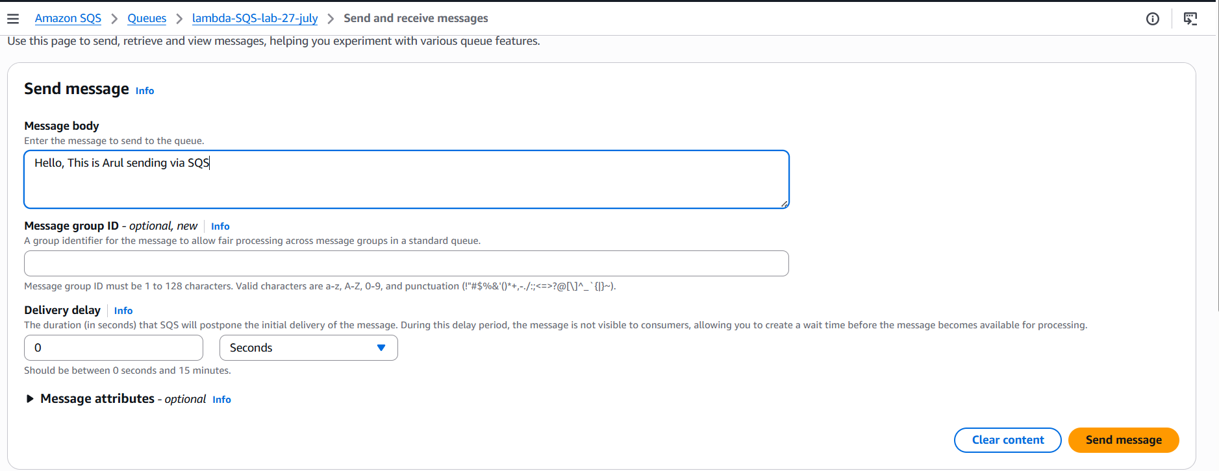
Message ID: 29d89100-e7e9-4274-999f-877b08e3e81d
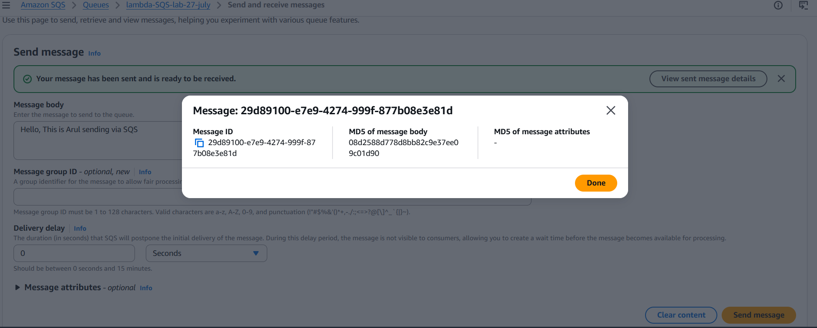
8. Lambda polls the queue : Verified the log under cloudwatch monitoring
